**MARKETING AND COMMUNICATIONS OFFICER**

**RECRUITMENT PACK**

**May 2024**

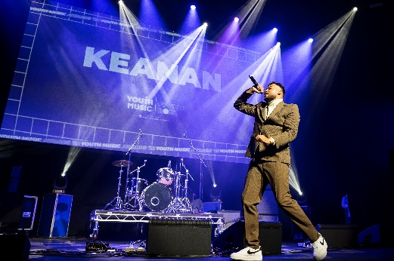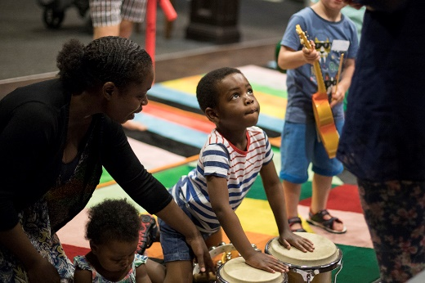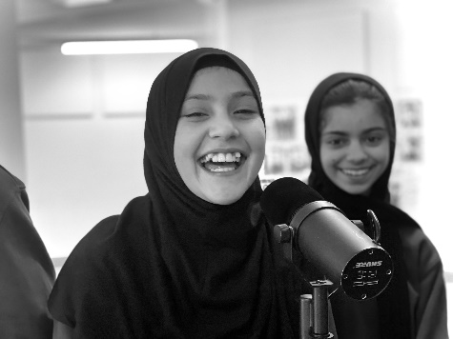

Photo Credits: New Writing North, Keanan (Youth Music Awards 2022), Brighter Sound

What we do

[**We are Youth Music**](https://www.youtube.com/watch?v=jrn2gnILY0c)**.** We’re the UK’s leading young people’s music charity. And we believe that every young person should have the chance to make, learn and earn in music and wider creativity. Yet our research shows that many can’t because of who they are, where they’re from or what they’re going through.

We leverage our insights, investment, and influence to build a national grassroots infrastructure that ensures the future of music is more inclusive, diverse, equitable and accessible.

Youth Music is a national charity funded thanks to the National Lottery via Arts Council England, players of People's Postcode Lottery and support from partners, fundraisers and donors.

For more information, visit [www.youthmusic.org.uk](http://www.youthmusic.org.uk). Read more about our funding programmes on the [Youth Music Network](https://network.youthmusic.org.uk/).

“I joined Youth Music after completing an internship post university. It has been amazing. I’ve developed a lot both professionally and personally. This is due to the supportive and inclusive nature of Youth Music. I find communicating with my colleagues easy and effortless. I wanted to work for an organisation with a good vision, goal, and environment which Youth music has proven itself to be and more. My colleagues on every level, are open, kind, and ready to help in a timely manner. The atmosphere of Youth music is warm and inviting. I’m happy to be a part of such an amazing vision and goal” **– Temi, Finance & Admin Assistant July 2023.**

Diversity & Equal Opportunities

Youth Music is an equal opportunity and [Living Wage employer](https://www.livingwage.org.uk/what-real-living-wage). We are committed to attracting, recruiting and retaining diverse candidates. It’s important that our team reflects the communities we serve.

We are currently under-represented by individuals from a working-class background, the Asian/Asian British community and wider Global Majority, Disabled people, the Trans community and people of faith.

If you are Disabled and your application meets the minimum criteria for the post, we will offer you a guaranteed interview. Youth Music is a [Disability Confident](https://disabilityconfident.campaign.gov.uk/) Comitted Employer and we are committed to making adjustments that would support you in applying for, or carrying out the role.

Please contact [constance.dingri@youthmusic.org.uk](mailto:constance.dingri@youthmusic.org.uk) if you have a disability and/or access requirements or if you wish us to consider any other reasonable adjustments to ensure the interview process is fully accessible.

Salary and Benefits

**Salary:** £30,000 per annum (Full Time Equivalent), pro-rata if part-time

**Pension:** 8% of salary towards a non-contributory group pension

**Contract: Fixed Term contract to 31 March 2025, (with the potential to extend).** Ideally 5 days a week but we are open to receiving applications from candidates who are available for a minimum of 3 days a week. We operate a blended working approach where you will be required to work in the office two days a week, on Tuesdays and Wednesdays.

**Location:** The Print Rooms, 164 – 180 Union Street,London, SE1 0LH

**Holidays:** 25 days pro-rata plus public holidays and additional days over the Christmas period when the office is closed

**Additional benefits:**

* Learning and development opportunities.
* A loans programme to cover the initial cost of, for example a bike to cycle to work or gym membership.
* Death in service insurance.
* Critical illness insurance.
* Income protection insurance for illness.
* An employee assistance programme.

There is also an opportunity to fully engage in the staff led Values Committee, Environmental Working Group and the Inclusion, Diversity, Equality and Access (IDEA) working group.

**About The Role**

As a Marketing and Communications Officer, you'll leverage your creativity and proficiency in copywriting and editing across a variety of digital platforms. Your mission will be to enhance our brand's digital presence and convey our social purpose, with a focus on our brand-new website and multiple newsletters. With a keen eye for detail, you'll also create high-quality insight reports that demonstrate our impact and identify areas for improvement.

Your role extends to supporting PR tasks and collaborating with the Insights Team to maintain high data quality, to enhance newsletter targeting and distribution.

You'll report directly to the Digital Marketing Manager and collaborate closely with the Digital Content Officer, ensuring that the right content reaches the right audiences and our digital channels achieve optimal engagement and growth.

**About you**

You are a creative and analytical Marketing and Communications Officer, skilled at using digital marketing to build brand engagement and grow audience reach.

You have experience curating engaging content for websites and newsletters and developing and implementing digital marketing campaigns in collaboration with others.

Your understanding of user journeys and SEO will ensure that Youth Music’s new website is impactful, current and audience focused. Tasked with supporting projects from concept to completion, your organisational skills and ability to meet deadlines will be critical to your success.

You also excel in liaising with agencies and partners, and your analytical skills enable you to create reports and use data to inform marketing plans.

**Key responsibilities**

* Maintain a regular flow of engaging content for our websites and newsletters, ensuring consistency and audience engagement.
* Write copy for the website, newsletters, and occasionally for social media. Ensure all copy is engaging, informative, and tailored to the intended audience.
* Regularly update and maintain the company website. Liaise with internal partners to ensure all content is current and relevant.
* Support the development and implementation of digital marketing campaigns in collaboration with the Digital Content Officer (DCO) and the Digital Marketing Manager (DMM).
* Coordinate closely with website, content, and Google Ads Grant agencies to ensure seamless alignment with Youth Music’s digital marketing strategy.
* Work with the DMM and DCO to create detailed monthly and ad-hoc reports. Analyse data to gauge the effectiveness of marketing plans and identify areas for improvement.
* Implement SEO strategies to improve the visibility and ranking of the company’s website. Stay updated with SEO best practices and adjust website content accordingly.
* Provide support to the Head of Marketing and Communications with PR tasks.
* Collaborate with the Insights team to interpret data collected from marketing campaigns, the grants programme and audience research. And optimise our use of databases, ensuring the highest quality of data is maintained on Mailchimp for more effective newsletter targeting and distribution.

#### **General**

* Carrying out all such additional duties as are reasonably commensurate with the role.
* This job description is not necessarily an exhaustive list of duties but is intended to reflect a range of duties the post-holder will perform.

**Person specification**

**Essential**

* At least one year’s continuous experience working in a similar role.
* Experience writing and editing compelling and accessible copy for various platforms such as websites, newsletters and social media.
* Knowledge of SEO strategies and best practices to improve website visibility and ranking.
* Proficiency in updating and maintaining website content to ensure it remains current and relevant.
* An understanding of the principles of data protection.
* Experience using data and insights to inform digital marketing plans.
* Skills in database management, particularly in using databases like Mailchimp for targeted marketing efforts.
* Proven creative thinker, with ability to generate new, forward-thinking, and relevant ideas
* Strong communication skills to liaise effectively with agencies, internal partners, and team members.
* Knowledge of and commitment to inclusion, diversity, equality and accessibility.

**Desirable**

* Experience in a charity, agency, youth or music organisation.
* Experience overseeing a Google Ad Grant account.
* Experience using Drupal.
* Understanding of the music education and / or music industries landscape.
* Passion for music and interest in its benefits for individuals and society.

**How To Apply**

To apply please [visit our website](https://youthmusic.org.uk/work-for-us?gclid=Cj0KCQiAtvSdBhD0ARIsAPf8oNkoAVZRQNcafM2GZN-rBlpGx8Zl2zgY7ZjyYid9UQ7VUHBdp0Jziv8aAhNPEALw_wcB) you’ll need to complete the following, sending them to: [jobs@youthmusic.org.uk](mailto:jobs@youthmusic.org.uk) with the subject line ‘Marketing and Communications Officer’ .

* Application Form
* Applicant Details Form
* [Equal Opportunities Form](https://survey.alchemer.eu/s3/90317662/ee7f35c49446) (this is an online anonymous form to complete)

We also accept video/audio applications, please include the same information shown in the written application format.

Deadline for applications: **5pm, Friday 28th June 2024.**

Suitable candidates will then be invited to an in-person interview to be held on **Thursday 11th July 2024** at Youth Music’s offices. Youth Music will cover travel expenses for successful candidates that attend their interview.

Unfortunately, due to capacity, we will only be able to contact candidates that have been shortlisted to interview.

THE NATIONAL FOUNDATION FOR YOUTH MUSIC   
STUDIO LG01, THE PRINT ROOMS

164-180 UNION STREET, LONDON, SE1 0LH

REGISTERED CHARITY NUMBER: 1075032   
LIMITED COMPANY NUMBER: 03750674