

**DIGITAL MARKETING MANAGER RECRUITMENT PACK**

**August 2023**

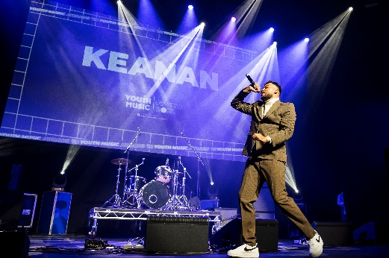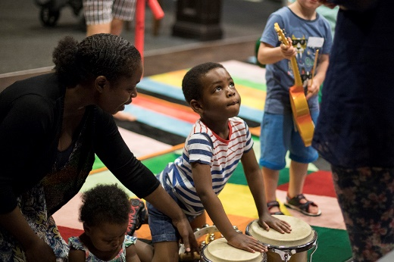

New Writing North, Keanan (Youth Music Awards 2022, credit: Will Ireland Photography), Brighter Sound (credit: Rachel Bywater)

What we do

We’re the UK’s leading young people’s music charity. We believe that every young person should have a chance to change their life through music. Yet our research shows that many can’t because of who they are, where they’re from or what they’re going through.

Through our insights, influence, and investment in grassroots organisations, we make sure more young people aged 0-25 can make, learn and earn in music nationwide.

Youth Music is a national charity funded thanks to the National Lottery via Arts Council England, players of People’s Postcode Lottery and support from partners, fundraisers and donors. Find out more about our work on the [Youth Music Website](http://www.youthmusic.org.uk/) and read more about our funding programmes on the [Youth Music Network](https://network.youthmusic.org.uk/).

Diversity & Equal Opportunities

Youth Music is an equal opportunities and Living Wage employer. We are committed to attracting, recruiting and retaining diverse candidates. It’s important that our team reflects the communities we serve. All our staff are members of an inclusion, diversity, equality and access (IDEA) working group to stimulate, inform and platform good IDEA practice at Youth Music.   
  
We especially welcome applications from people from under-represented groups and are committed to making adjustments that would support you in applying for or carrying out the role. We are currently under-represented by people from within the Trans community, people from the LGBTQ+ community, Disabled people and people from the Global Majority. If you are Disabled and your application meets the minimum criteria for the post, we will offer you a guaranteed interview.  
  
Please contact [constance.dingri@youthmusic.org.uk](mailto:constance.dingri@youthmusic.org.uk) if you have a disability and/or access requirements to ensure the interview process is fully accessible. [**Our Equality, Diversity and Inclusion Statement**](https://youthmusic.org.uk/equality-diversity-and-inclusion-statement)

Salary and Benefits

**Salary: £35,000 - £40,000** dependent on skills and experience

**Pension:** 8% of salary towards a non-contributory group pension

**Contract:** Permanent, Full Time, 37.5 hrs p/week

We operate a blended working approach where you will be required to work in the office two days a week, with Wednesdays being a all staff day.

**Location:** The Print Rooms,London, SE1 0LH

**Holidays:** 25 days (amend this is part time role) plus public holidays and additional days over the Christmas period when the office is closed

**Additional benefits:** These include death in service insurance, critical illness insurance, income protection insurance for illness, employee assistance programme, learning and development opportunities, a staff values committee, cycle to work scheme, and a loans programme to cover the initial cost of for example a gym membership.

About The Role

We are looking for a digital savvy marketeer to co-create and deliver our strategy to achieve Youth Music’s marketing objectives to:

* Grow awareness of Youth Music as the leading voice of young people and music.
* Demonstrate the impact of Youth Music’s work and partnerships.
* Inspire inclusive practices amongst Projects and Professionals working with young people in music.
* Build the credibility of Youth Music amongst creative career starters.

You’ll lead multiple integrated campaigns each year, working closely with the Head of Marketing & Communications, the Digital Content Officer and a pool of talented young freelance creatives – [“NextGen”](https://youthmusic.org.uk/nextgen). In 2024, we’ll celebrate 25 years of Youth Music – and you’ll play a key role in bringing this to life across the digital landscape. You’ll also ensure the [Youth Music Awards](https://youthmusic.org.uk/awards) engages our target audiences with an exciting digital marketing campaign.

You’ll have wide scope to implement change, by working with a newly appointed agency to oversee our upcoming website development project. Alongside this, you’ll review our e-newsletter ecosystem to grow audience reach and engagement, and you’ll improve our impact through SEO and PPC.

About you

We are looking for someone with a breadth of experience in digital marketing. You’ll know how to plan based on audience insights and marketing objectives, and you’ll be skilled in juggling multiple priorities.

You’ll be a highly motivated, insights driven marketer with a track-record for planning, executing, and analysing effective campaigns. Bringing with you multichannel experience including social media, websites, email and paid media, you’ll be keen to make your mark on a growing brand with social purpose. You’ll have line management experience, or transferable skills in this area.

How To Apply

To apply please [visit our website](https://youthmusic.org.uk/work-for-us?gclid=Cj0KCQiAtvSdBhD0ARIsAPf8oNkoAVZRQNcafM2GZN-rBlpGx8Zl2zgY7ZjyYid9UQ7VUHBdp0Jziv8aAhNPEALw_wcB) you’ll need to complete the following, sending them to: [jobs@youthmusic.org.uk](mailto:jobs@youthmusic.org.uk) with the subject line ‘Digital Marketing Manager Application’.

* Application Form
* Applicant Details Form
* [Equal Opportunities Form](https://survey.alchemer.eu/s3/90317662/393bb71a1fdd) (this is an online anonymous form to complete)

We also accept video/audio applications, please include the same information shown in the written application format.

Deadline for applications: 9am on Monday 11th September 2023.

We operate a two-stage interview process, and send interview   
questions in advance to shortlisted applicants.

* Stage One: Abbi Oakley, Head of Communications/Marketing will offer shortlisted candidates a telephone interview on Thursday 14th September 2023.
* Stage Two: Suitable candidates will then be invited to an in-person interview to be held on Thursday 21st September 2023 at Youth Music’s offices.

**Contact Us**

Phone: +44 (0) 207 902 1060  
Email: [jobs@youthmusic.org.uk](mailto:jobs@youthmusic.org.uk)  
Website: [www.youthmusic.org.uk](http://www.youthmusic.org.uk/)

THE NATIONAL FOUNDATION FOR YOUTH MUSIC   
STUDIO LG01, THE PRINT ROOMS

164-180 UNION STREET, LONDON, SE1 0LH

REGISTERED CHARITY NUMBER: 1075032   
LIMITED COMPANY NUMBER: 03750674